# Lesson 15 – Lists

* What is a list?
* Basic Operations with lists

What students should know

**2h**

A list is a set of nodes arranged linearly (one after the other). Each node contains, in addition to its data, a pointer pointing to the next node. The pointer of the last node does not point to a node and it is NULL.

## Create a list

A list in B4X is declared as follows:

**Private** Islands **As List**

Islands.**Initialize**

Where Islands is the name of the list created. In addition, a list to be used must be initialized using the initialize method.

Items are imported into the list using the Add method, which adds a new item to the end of the list.

Islands.**Add**(“Piraeus”)

Islands.**Add**(“Paros”)

Islands.**Add**(“Thira”)

Islands.**Add**(“Crete”)

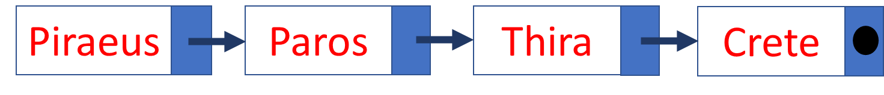

You can also insert items in a table at the end of the list with the AddAll command.

Islands.**AddAll**(Array as String(“Piraeus”, “Paros”, “Naxos”, “Crete”))

**Remember**

List items counts from 0. So, a list with 4 elements has the element(0) until element(3)



## Insert an item in a specific location

To insert between two elements you can use the **InsertAt** property

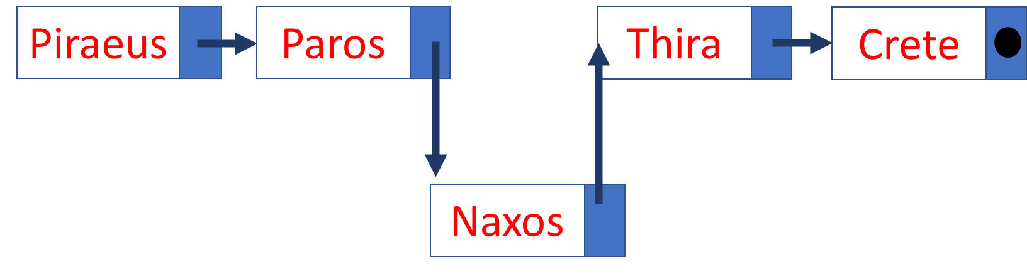

Islands.**InsertAt**(2, “Naxos”)

In the above example the island of Naxos is inserted between Paros and Thira.

## Remove an item from a specific location

The RemoveAt command removes a list item from a specific location.

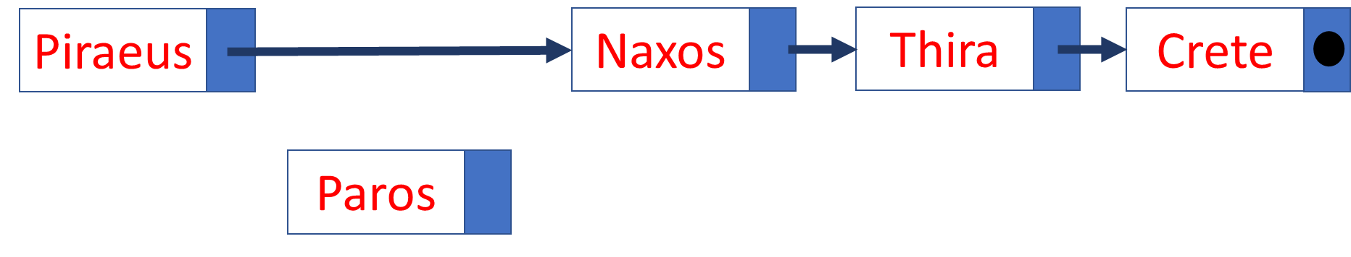

Islands. RemoveAt(1)

In the example above, Paros’s island is removed from the list.

## Change position value

With the Set command you to change the content of a location with another value that you enter.

Islands.Set(4, “Rhodes”)

Here the value of 5th place changes to "Rhodes".

## More commands in lists

1. List size.



Islands.**Size**

The example above returns the value 5.

1. Sort a list. You can sort a list in ascending or descending order with sort

Islands.**Sort**(True) ' Sortby ascending order

Islands.**Sort**(False) ' Sortin descending order

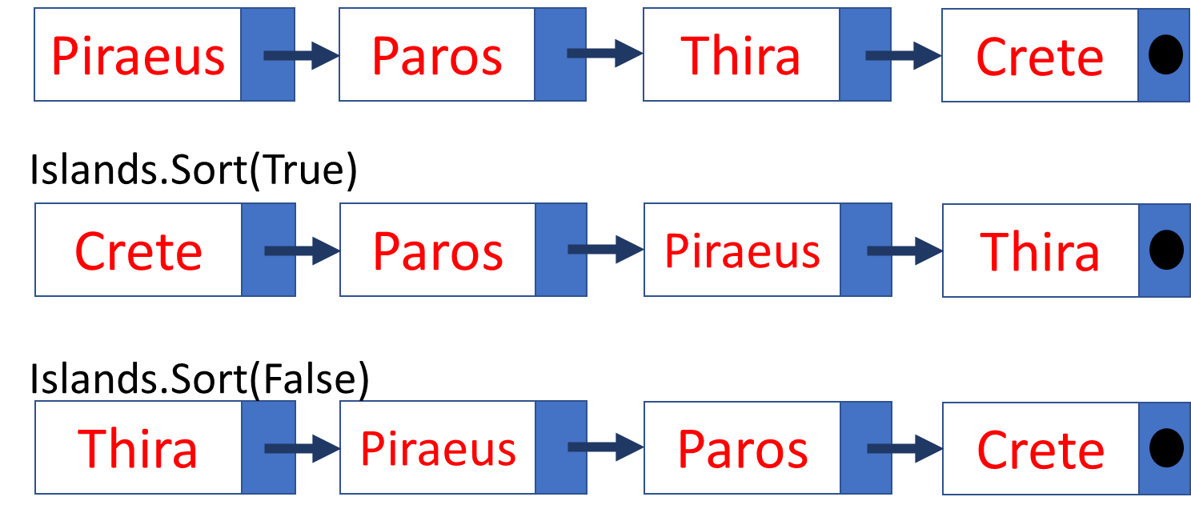

1. Empty List

A list empties with the Clear command

Islands.**Clear**

1. Move through a list

Moving within a list with a repetitive command

**For** i = 0 **to** Islands.**Size** – 1 ‘Remember it begins from 0

**Log**(islands.**Get**(i))

**Next**

1. You can take advantage of the values in a list by assigning its values to other variables:

**For** i = 0 **to** Islands.**Size** – 1

**Private** isle **As String**

Isle = islands.**Get**(i)

**Log**(Isle)

**Next**

1. Insert other types of items

A list can store items of any simple or complex type you want. For example, each item in a list could be an object or an entire table.

In the following example, each item in a list is an integer table:

'Create a list of arrays

**Private** StudentsGrades **As List**

StudentsGrades.Initialize

**For** j = 0 **To** 4

**Private** Grades(5) **As Int**

**For** i = 0 **To** 4

Grades(i) = Rnd(1, 100) 'Create 5 random Grades For student

**Next**

StudentsGrades.Add(Grades)

**Next**

'Show Students Grades

**For** j = 0 **To** StudentsGrades.Size - 1

**Log**("Student: " & j)

**Private** stGrades(5) **As Int** = StudentsGrades.Get(j)

**For** I = 0 **To** 4

**Log**(stGrades(i))

**Next**

**Next**

1

2

3

4

5

1. The list is declared and initialized
2. For 5 elements in the list, an equal number of tables are created with random numbers between 1 and 100
3. Each table is placed at the end of the list with the Add command
4. For all items in the list, a table is filled by the item in the list
5. The table we got from each item is displayed.

## Exercises

* 1. Create a list of Country and Capital Names. For example, you can use the following countries.

|  |  |
| --- | --- |
| CUBA | HAVANA |
| CYPRUS | NICOSIA |
| CZECHIA | PRAGUE |
| EGYPT | CAIRO |
| KENYA | NAIROBI |
| MEXICO | MEXICO CITY |
| PERU | LIMA |
| VIETNAM | HANOI |
| PORTUGAL | LISBON |

Source: <https://www.boldtuesday.com/pages/alphabetical-list-of-all-countries-and-capitals-shown-on-list-of-countries-poster>

* 1. Display the names of countries starting with the letter "P"
  2. In an appropriate text field, enter name of a country and then search the list if that country exists and display the capital city.
  3. Make a button to show a dialog asking for new country and capital and add it to list.